Patron Billing Manual

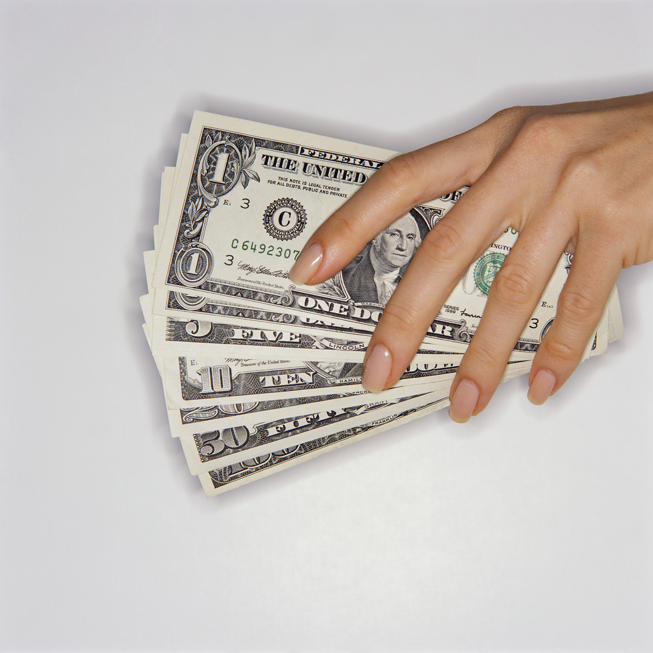

The patron billing process includes four parts: 1) The file saving and sending to patrons of Billing related circulation notices, 2) The exporting of library patron billing information to the campus financial systems, 3) The downloading of library patron payment information from the campus systems and the subsequent uploading of that data into the ILS, updating our patron records, and 4) The running of the negative charge purge in the ILS.

The following document outlines these four processes.

- File Saving & Sending Billing Notices to Patrons
Fall 2008

The following procedures outline the steps involved in saving electronic copies of circulation billing notices (i.e. Credits, Bills, Fines, & Manual Fines) and the subsequent sending of those notices to our patrons. The process is as follows:

- Log into Millennium Circulation, set your initials into memory, and then click on the Notices button. Something similar to the following window will then appear:

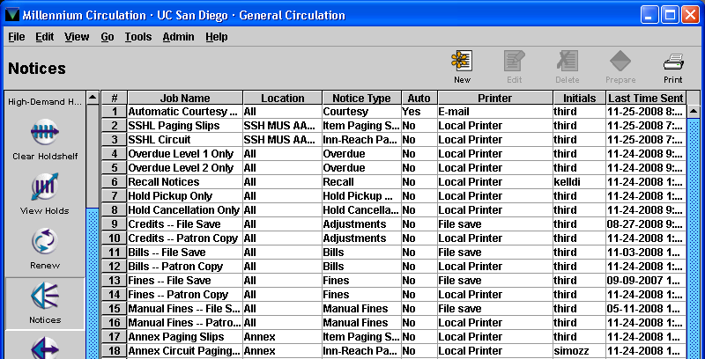

Notice, as in the above example, that each type of circulation billing notice is referenced in two rows, one labeled as “File Save” and the second as “Patron Copy.” The File Save options are programmed to create an electronic copy of the notices, while the Patron Copy options actually send the notices to the respective patrons.

- Locate and single-click on the File Save row for the first billing notice type ( “Credits – File Save” in the above example), highlighting it blue.
- In the upper right corner of the window, click on the Prepare button. Millennium will then open a Notices Job window and display a Select Form Printer dialog:

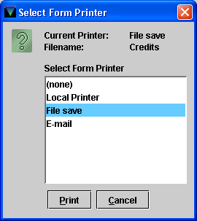

Notice that the File Save printer option is pre-selected for you.

- In the Select Form Printer dialog, click on the Print button. MilCirc will then display an Input dialog for you to enter a file name for this print job:

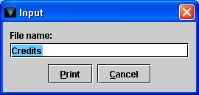

Notice that a file name is already entered for you for that notice type.

- In the Input dialog, click on the Print button to continue. Millennium will then prepare the notices and display a window similar to this:

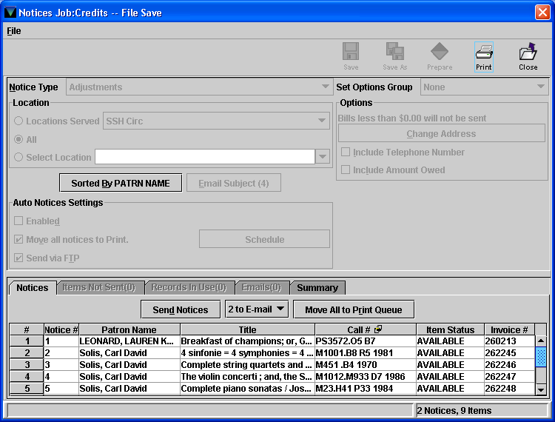

- Next, click on the Move All to Print Queue button, highlighted in the above example. Millennium will then display a Warning dialog and ask you if you are sure that you wish to do this.
- In the Warning dialog, click on the Yes button. At this point, using the above example, the previously “2 to E-mail” button is now labeled “2 to Print.”
- Now, click on the Send Notices button to initiate the file save. Millennium will then display a Send Notices dialog similar to this:

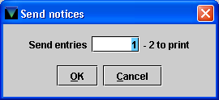
- In the Send Notices dialog, click on the OK button. Millennium will then process the file save job and then display a second Send Notices dialog similar to this:

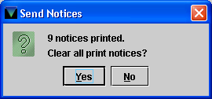

- VERY IMPORTANT!! AFTER COMPLETING THE FILE SAVE JOB, ALWAYS CLICK ON THE NO BUTTON IN THIS CIRCUMSTANCE. If you click on the Yes button, all of these notices will be deleted from the system and you will not be able to easily send the patrons their copies.
- Finally, in the upper right corner of the window, click on the Close button twice to exit this task window.
- Now it is time to process the notices for our patrons. Locate and single-click on the Patron Copy row for the first billing notice type ( “Credits – Patron Copy” in the above example), highlighting it blue.
- In the upper right corner of the window, click on the Prepare button. Millennium will then open a Notices Job window and display a Select Form Printer dialog:

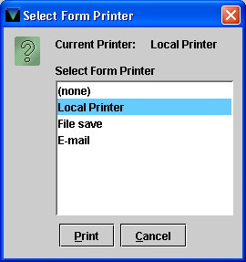

Notice that the Local Printer option is pre-selected for you.

- In the Select Form Printer dialog, click on the Print button. MilCirc will then display a Print (Form Printer) dialog:

. 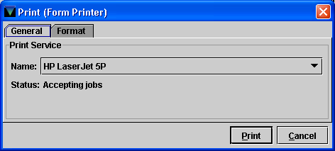

- In the Print (Form Printer) dialog, use the drop down menu to select the printer that you want the print notices to be sent to. Once selected, click on the Print button. Millennium will then prepare the notices and display a window similar to this:

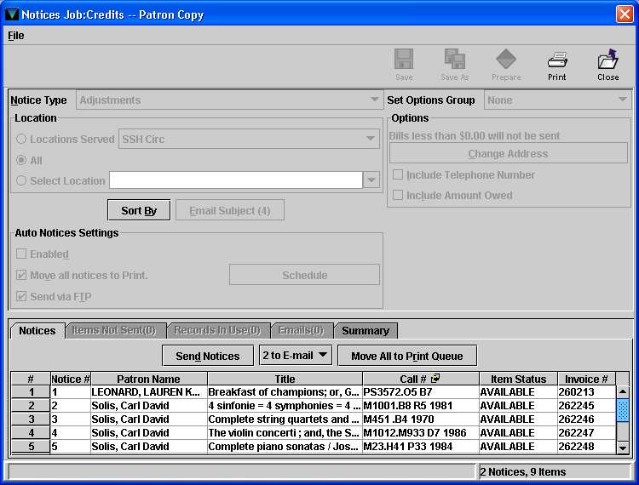

- To send notices to patrons who have provided the Library with an email address, click on the Send Notices button. Millennium will display a Send Notices dialog similar to this:

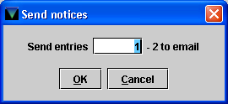

- In the Send Notices dialog, click on the OK button to initiate the sending of the notices. Once done, Millennium will display a second Send Notices dialog similar to this:

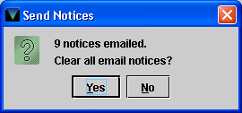

- In this second Send Notices dialog, click on the Yes button to remove the notices from the queue. Millennium will then automatically switch to the queue for the notices to be printed (which there very rarely is). If there are notices to be printed, then click on the Send Notices button again and follow the prompts to print and clear the notices from the queue. Fold and mail the notices as appropriate.
- Lastly, click on the Close button twice in the upper right corner of the window.
- Repeat the above steps for each of the other notice types (i.e. Bills, Fines, & Manual Fines).

The following steps outline the procedures for exporting the file saved notices files out of Millennium to your desktop or a location of your choosing for saving and record maintenance.

- Once each notice type has been file saved and sent to our patrons, in the left most column of MilCirc locate and click on the Data Exchange module. Millennium should display a window similar to this:

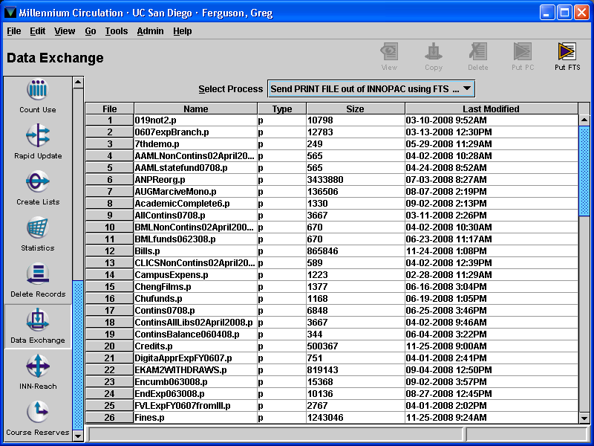

- Click into the “Last Modified” column header to sort the list by the last modified date.
- Scroll down to the bottom of the list to view those files modified today and locate your file saved notices files.
- Select each file to transfer, holding down the Ctrl key on your keyboard to select multiple files, highlighting each blue.
- Next, in the upper right corner of the window, click on the Put PC button. Millennium will then display a Save dialog similar to this:

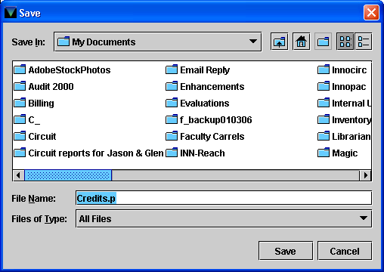
- Click into the Save In: drop down menu to browse to the location that you wish to save the files.
- Once a location is identified, click on the Save button. Millennium will then download and save copies of the files at the designated location.
- Now that the files have been saved elsewhere, make sure that they are selected in Millennium and then click on the Delete button in the upper right corner of the window. Millennium will display a Delete Files dialog similar to the following:

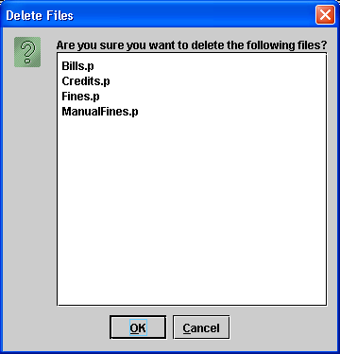

- In the Delete Files dialog, click on the OK button to confirm the deletion command.

II. Exporting Circulation Billing Data
Updated Fall 2008

The UCSD Libraries transfer patron billing information (i.e. fines, replacement bills, adjustments, etc.) to the campus IFIS/ISIS system for payment collection. The process begins in the Integrated Library System (ILS) and utilizes a third party interface to reformat the data to conform to campus and Library requirements.

The process for exporting patron billing information to the campus systems is as follows:

1. Log into the ILS (currently the character-based INNOPAC system).

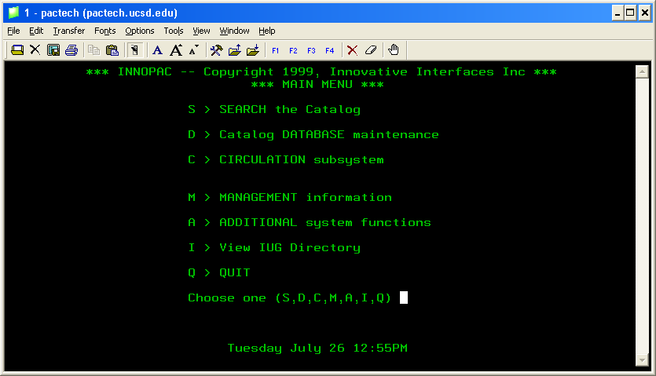

2. From the main menu (above), select C > CIRCULATION subsystem.

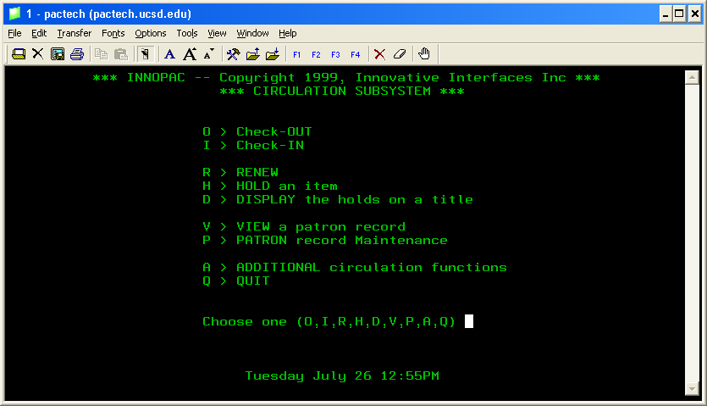

3. Next, select A > ADDITIONAL circulation functions.

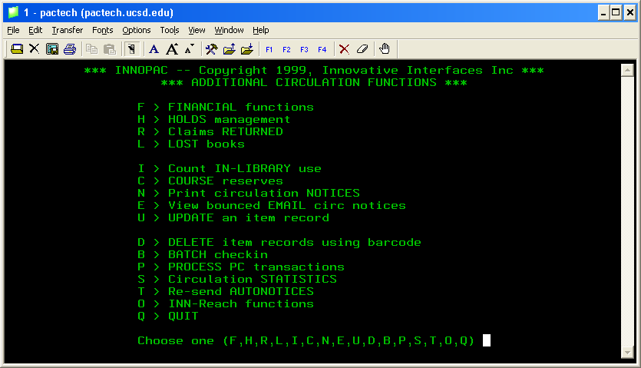

4. Select F > FINANCIAL functions and enter your INNOPAC/MilCirc initials and password.

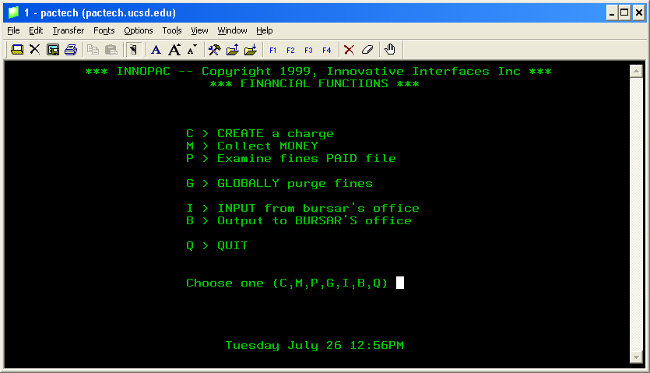

5. Select B > Output to BURSAR’S office and enter your INNOPAC/MilCirc initials and password.

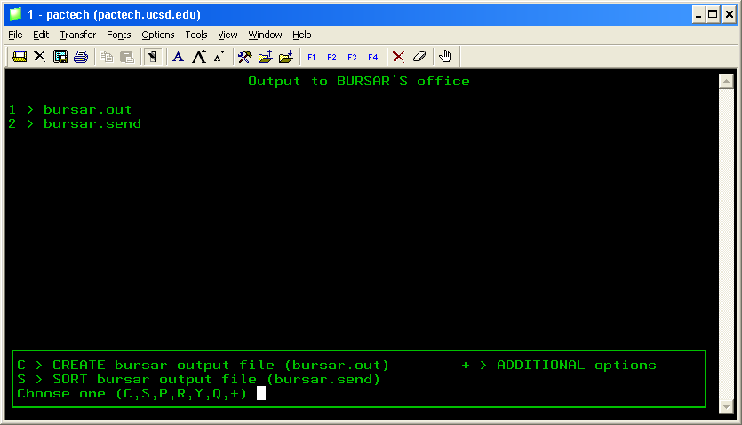

6. Select R > REMOVE files.

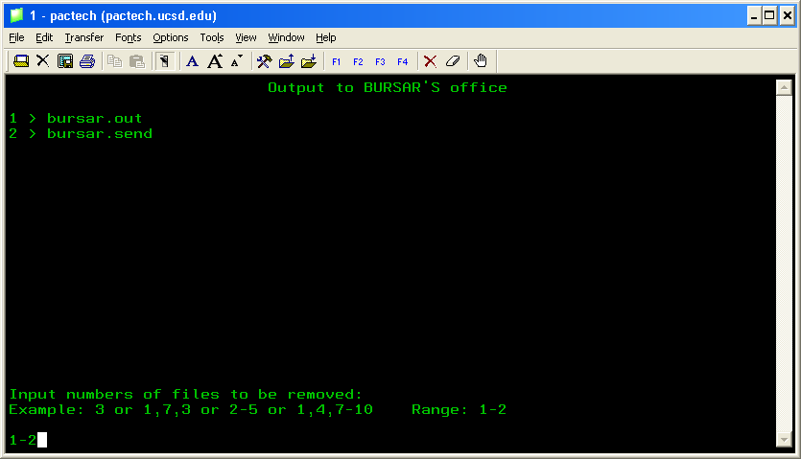

7. Type 1-2 (as above), then press Enter to remove the previous bursar files.

8. Press C > CREATE bursar output file (bursar.out).

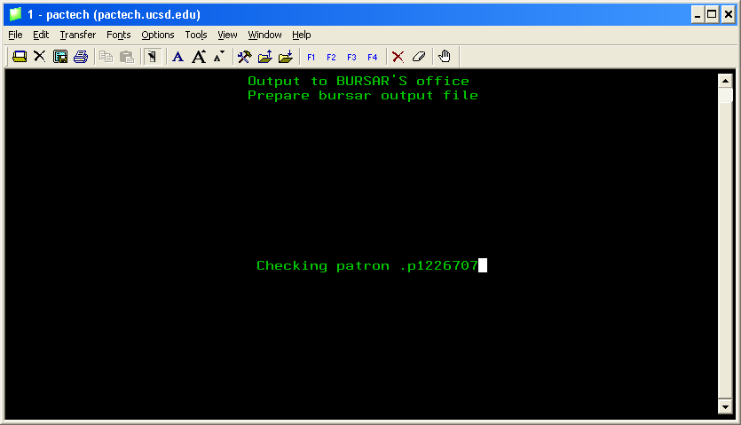

INNOPAC will now create the new billing file (bursar.out). Once completed, you will see something similar to the following screen:

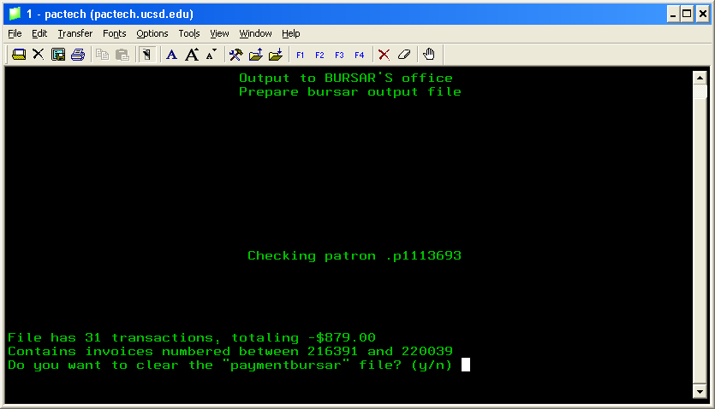

9. To the question “Do you want to clear the ‘paymentbursar’ file? (y/n)” select Y (YES).

10. Next, select S > SORT bursar output file (bursar.send).

You should then see the following screen:

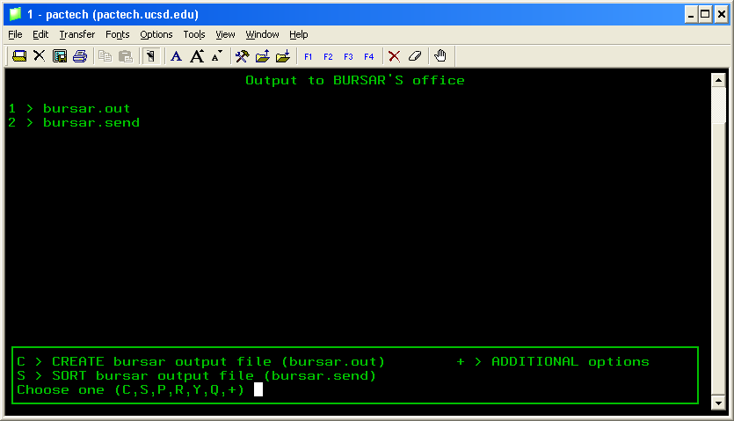

11. If you want to confirm that you have the current file, select Y > DISPLAY file SIZE & DATE.

You should see something similar to the following screen:

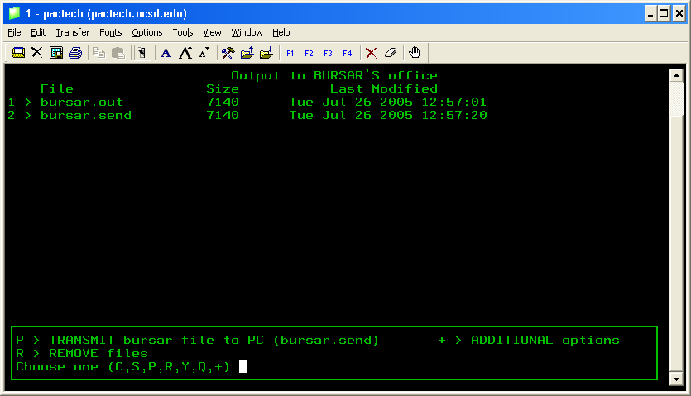

12. Next, select P > TRANSMIT bursar file to PC (bursar.send).

13. From the list of IP addresses that will appear, select the line number of IP 132.239.119.230 (line #2 below), then press Enter.

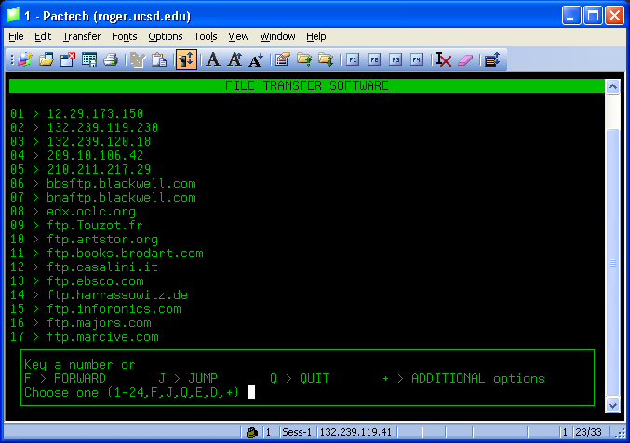

14. As prompted, enter the username “anonymous”.

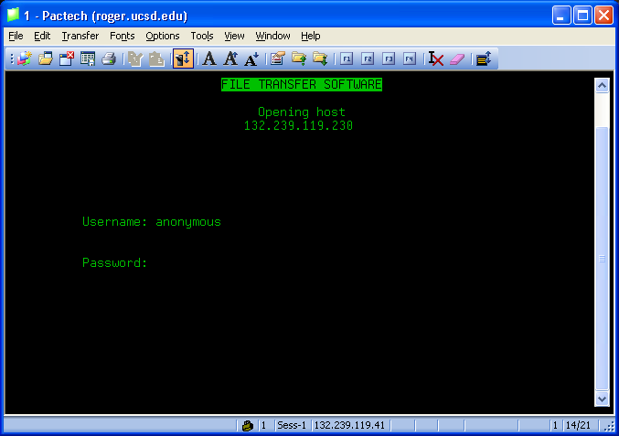

15. As prompted, enter your full UCSD email address (i.e. jsmith@ucsd.edu) as the password.

You should now see a screen similar to the one below. Notice in the upper right corner the text [bin][PROMPT].

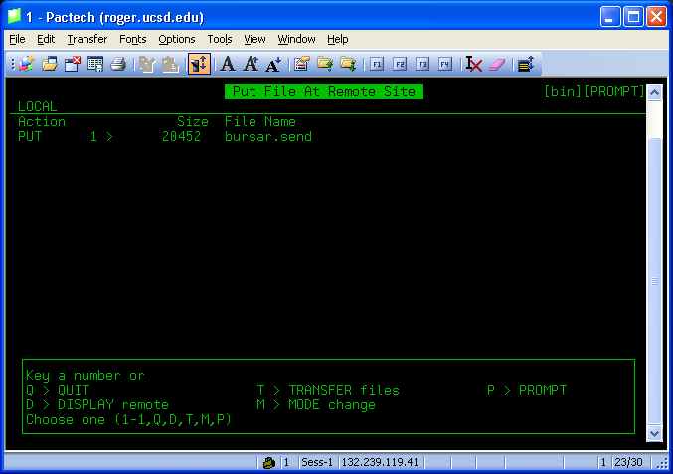

16. Select M > MODE change to alter the mode from [bin] to [ASCII] (see below).

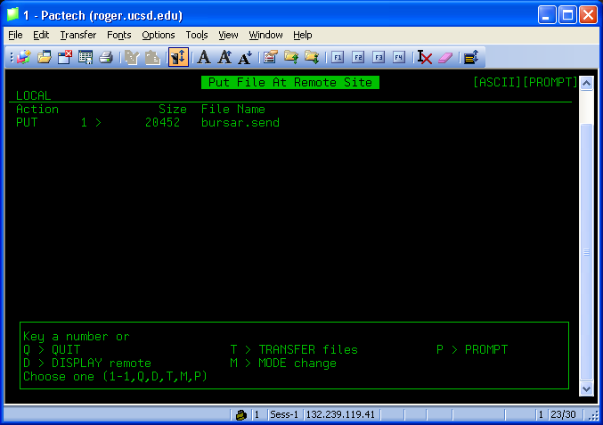

17. Select D > DISPLAY remote.

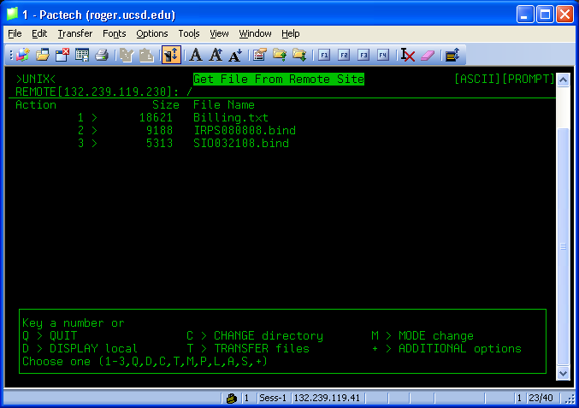

- Select C > CHANGE directory and INNOPAC will display a new window within this screen.

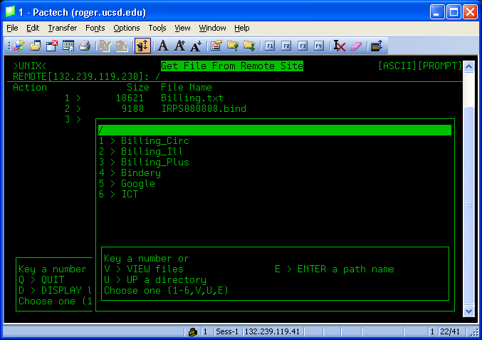

- Select the row number for the “Billing_Circ” option (1 in the example above).

- Upon doing so, verify (see below) that the directory “Billing_Circ” now displays in the upper left corner of the smaller window.

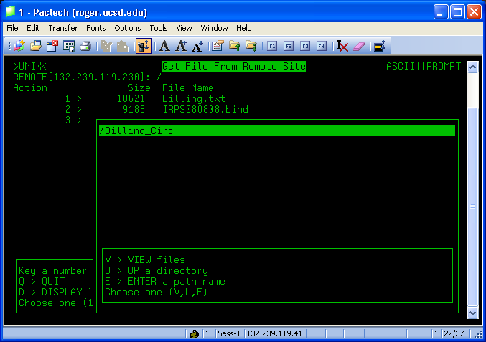

- Select V > VIEW files.

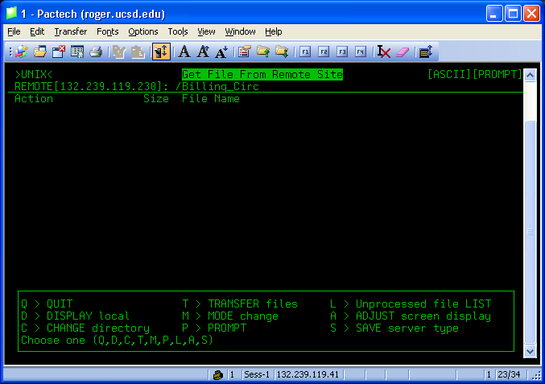

- Select T > TRANSFER files.

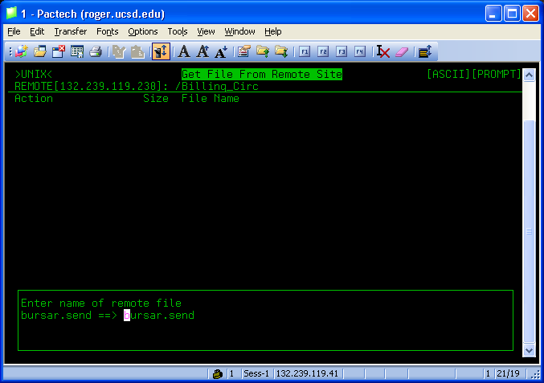

INNOPAC will continue to use the default file name of ‘bursar.send’. At this point, you need to change it.

24. Change the file name from ‘bursar.send’ to ‘Billing.txt’ (as below), then press Enter.

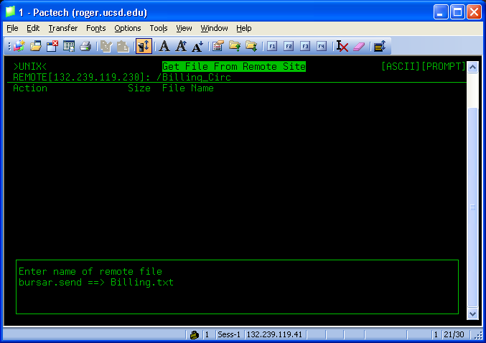

Once the file transfer is complete, you should see a screen similar to this:

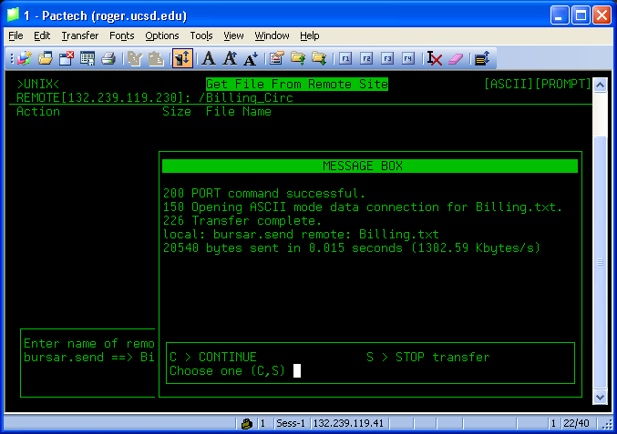

25. Select C > Continue.

26. Select Q > Quit.

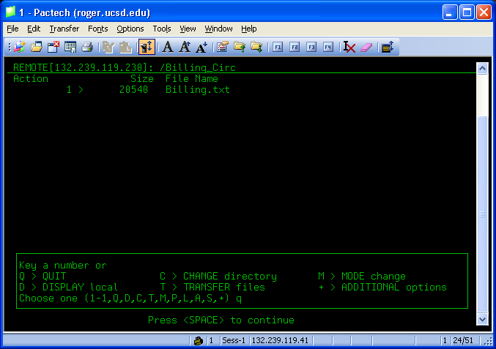

27. Upon seeing the above screen, press Space to continue.

28. Select Q > Quit until you get to the Circulation Subsystem menu.
29. Select P > PATRON record Maintenance, entering your INNOPAC initials and password.

30. Minimize the INNOPAC window until deemed necessary.

31. On your desktop, double-click on the UCSD Library Patron Billing icon.

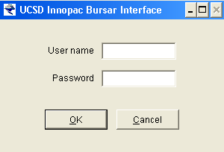

32. As prompted (see above), enter your username and password for the program.

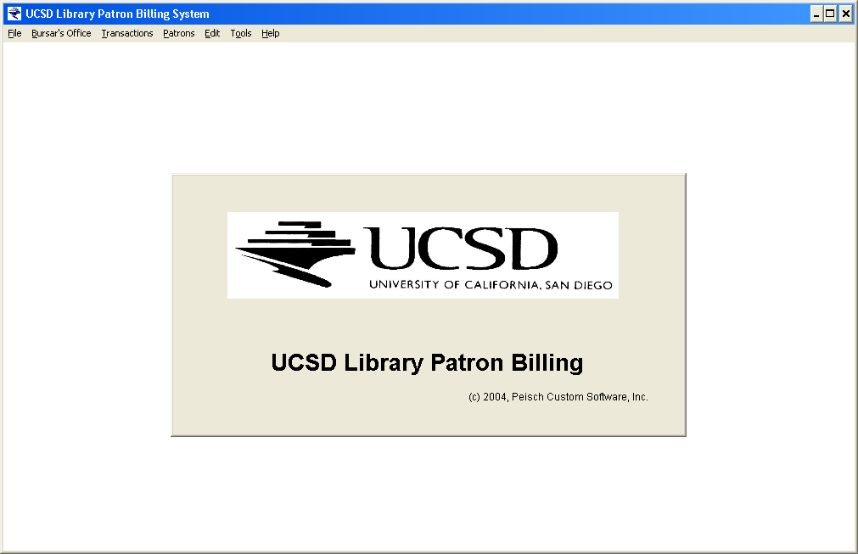

Once you are logged in, you should see the above display.

33. Under the File menu, select Import a Billing File.

You should then see a window similar to this:
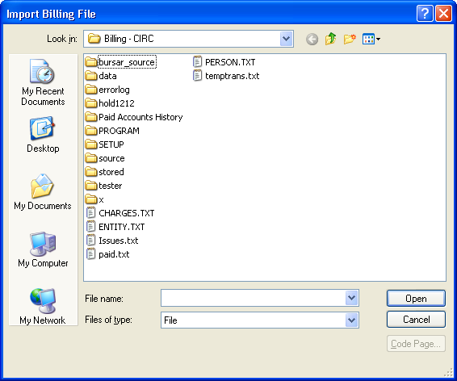

34. Under the Look in: menu change the drive labeled “billing_circ on anfalas” (see below).

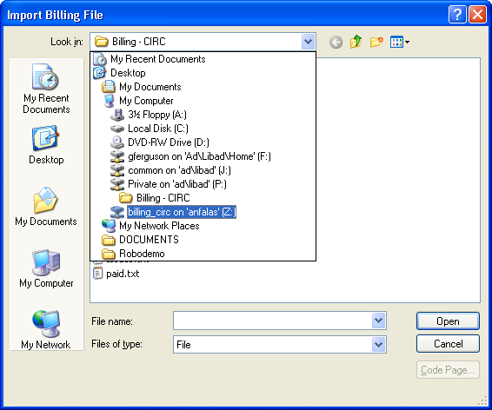

35. Within the “billing_circ on anfalas” double-click on the Billing.txt file.

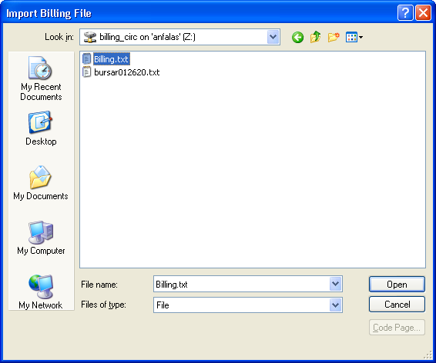

The Billing software should begin processing the file, as indicated by the small window in the upper right corner of the screen (see below).

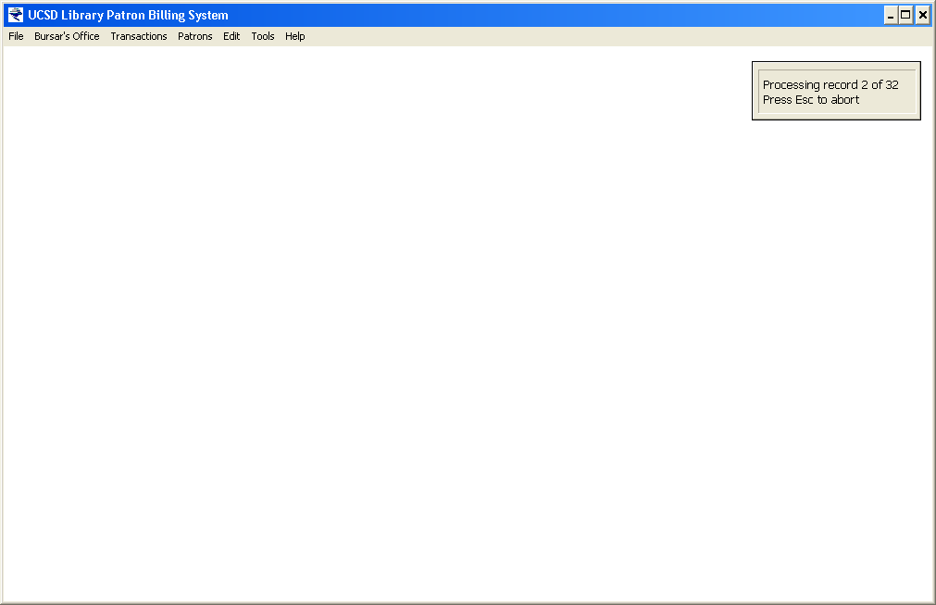

Once the file is completely processed, a message will appear telling you that the import was complete.

36. Under the Transactions menu, click on the Pending Queue option to confirm that the data arrived.

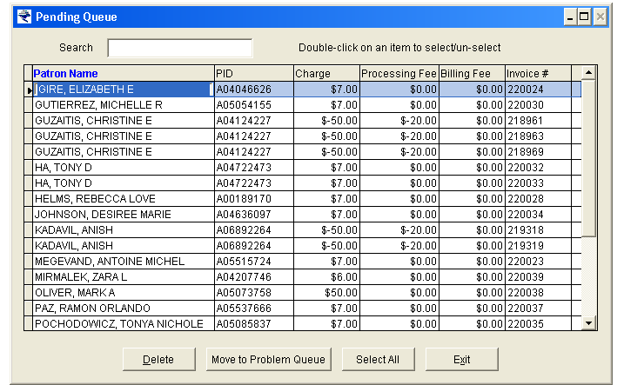

Here you can delete entirely or move selected transaction lines to the Problem Queue.

37. Click Exit to close the Pending Queue window.

38. Next, under the Transactions menu, click on the New Patrons option.

If a patron is being processed through the Billing software for the first time, you will find them listed here.

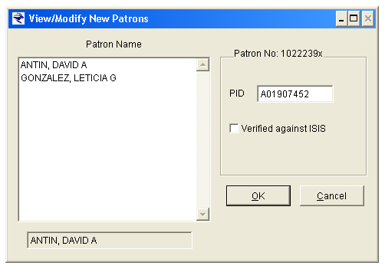

The procedure at this point is to verify if the patron has an active account on ISIS. Sometimes, as in the example above, the patron data will include a campus billing account number (i.e. an A-number), referred to as their PID in the Library. However, it is quite common that the patron data will not include an A-number and you will need to check ISIS.

39. If an A-number is included with the patron data and you confirm that the account is correct and active in
ISIS, click in the “Verified against ISIS” checkbox (see below).

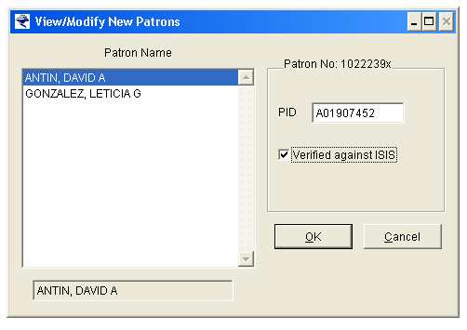
40. If no A-number was included with the patron data, the PID field in the New Patrons window will be blank
when you click on the patron name (see below).
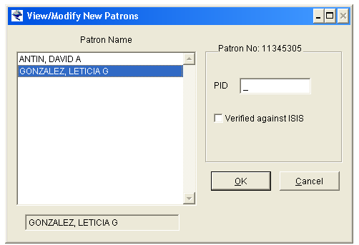

At this point, you must see if the patron has an active account on ISIS. If not, you must create one, and then copy the new A-number and paste it into both the PID field in the patron’s record in Millennium Circulation/INNOPAC and the PID field in the New Patrons window (see below).

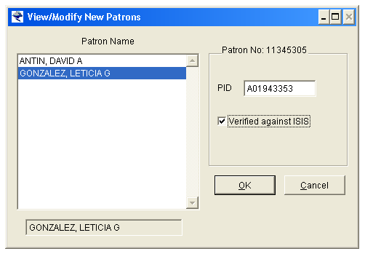
Once the new A-number is in the PID field of the New Patrons window, click in the “Verified against ISIS” checkbox.

41. Once all of the new records are verified and marked, click the OK button to exit the module.

- Next, under the Transactions menu, click on the Problem Queue option. If there are no transactions listed in the Problem Queue, please skip the following section to #36.

The Problem Queue is a table populated by transactions from the incoming Billing.txt file that the software identified problems with. The reasons why a transaction will appear in the Problem Queue vary. Here are some of the most common “problems” that you will encounter:

Problem Message | Description | Action
"New patron is missing an address" | No address information came over with the transaction data for this new patron. | This is a purely informative problem message. Select the transaction in the Problem Queue and move it to Pending.
"Patron is missing a PID" | The patron data associated with this billing transaction did not include a PID. | Ideally, you identified this person in the New Patrons table and already created and/or confirmed their A-number in ISIS. If so, select the transaction in the Problem Queue and move it to Pending. If not, then go to the New Patrons Queue and do so.

Problem Message | Description | Action
"Patron's PID doesn't match the one from Innopac. Theirs is..." | The PID that came over with this transaction does not match the PID in the billing software database. | See procedures below.

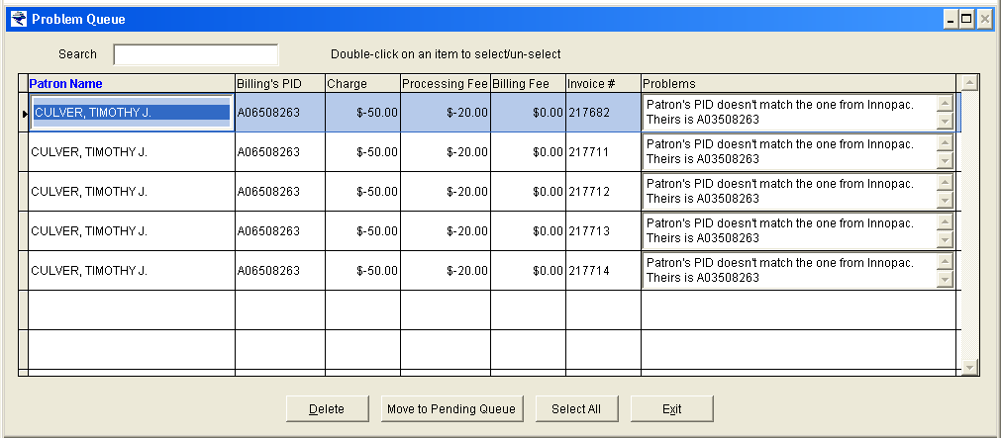

- Double-click on the patron name.

You should then see a Patron History detail window:

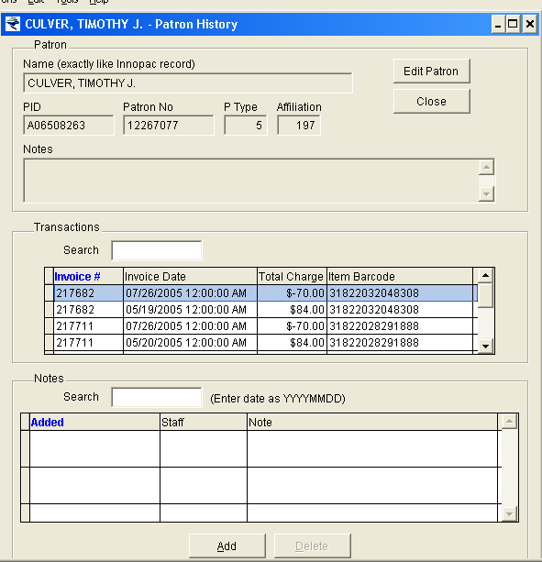

- Click on the Edit Patron button and the data boxes in the Patron section of the window will become active. You should see the “old” PID number in the PID field:

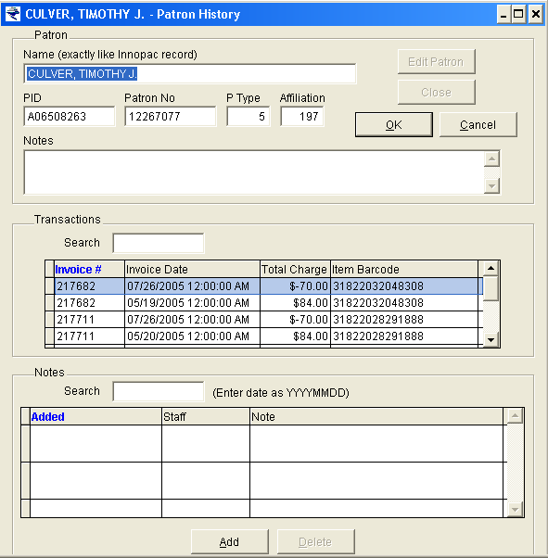

- Select and copy the patron name, using CNTRL-C to copy (NOTE: In the Billing Software, you cannot use the right-click button on the mouse to bring up a copy and paste menu).

- In MilCirc or INNOPAC, paste the copied name in the appropriate module and retrieve the patron record.

- In the retrieved patron record, locate and identify the patron record number and compare it to the Patron No. data in the Billing Software.
- If the patron record numbers and names match, then copy the PID from MilCirc/INNOPAC and paste (CNTRL-V) it over the A-number in the Billing Software, clicking OK to save the change and Close to exit.

- If the patron record numbers and names DO NOT match, then you retrieved the wrong patron record in MilCirc/INNOPAC. Try again, but if you prefer an alternative, you may copy the Patron No. information from the Billing Software and use it to retrieve the patron record in MilCirc/ INNOPAC.

Message | Description | Action
"Possible duplicate transaction" | A duplicate transaction may already exist in the transaction database. | See procedures below.

- Double-click on the patron name. You should then see a Patron History detail window:

- In the middle section of the window, you should see the patron’s transaction history.

- Using the browse bar, search for the invoice number detailed in the Problem Queue transaction and check for duplication on an earlier invoice date. Remember: You are not solely looking for a duplicate invoice number (bills and adjustments share that information), you are checking to see if we are attempting to charge or credit them an additional time.

(NOTE: You should be able to click-and-drag both the Patron History and Problem Queue windows within the Billing Software so that you can easily compare the information.)

- If you DO locate a duplicate transaction, then return to the Problem Queue, select the transaction, and click on the Delete button. Report the incident to the ILS Circulation Module Coordinator.
- If you DO NOT locate a duplicate transaction, then contact the ILS Circulation Module Coordinator for assistance. If he/she is not available, simply leave the problem transaction in the Queue until such time as it can be confirmed.
In addition to the aforementioned problem messages, there are six additional system messages that require administrative response. If you see any of the following messages, please contact the ILS Circulation Module Coordinator:

Message | Description | Action
"Bad charge type" | A charge type indicated in the export file is invalid, possibly due to file corruption (very rare). | Contact the ILS Circulation Module Coordinator.
"Bad location code" | The item record location code in this transaction is not recognized by the application. | Contact the ILS Circulation Module Coordinator.
"Bad patron type" | The patron type in the import file is not recognized by the application. | Contact the ILS Circulation Module Coordinator.
"Charge type has no output code" | The charge type in this transaction is not mapped to an output code in the application. | Contact the ILS Circulation Module Coordinator.
"Charge type not found" | The charge type in the import file is not in the applications charge types table. | Contact the ILS Circulation Module Coordinator.
"Could not add item" | The application could not create an internal ID number and add the information to its database. | Contact the ILS Circulation Module Coordinator.

There will be times that you may want to act on multiple Problem Queue transactions at one time, such as move them all to the Pending Queue at once. To do this:

- Double-click within the transaction line in any of the amount fields. Upon doing so, you should notice the background color of the Problems box changes to Teal.

- Repeat the process on the other transaction lines that you wish to move. You will notice that as you click on each additional line, the previous transaction line you marked will become completely Teal; if you want to select all of them, simply click on the Select All button:

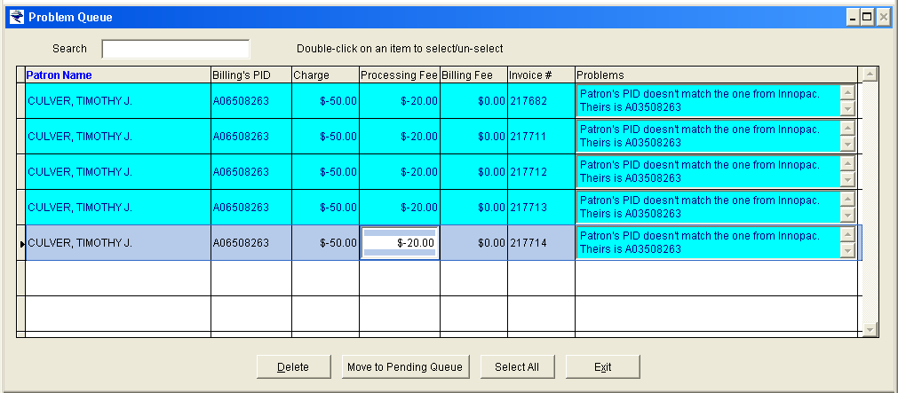

- Once you have selected all of the transactions, click on the action button of your choice.

- Now that you have processed everything in the New Patrons and Problem queues, access the Pending
Queue one last time and browse the list to confirm that each transaction is complete (i.e. there are no
blank fields). If you notice any problems, select the transaction line, move it to the Problem Queue
and resolve the issue before returning it to Pending.

- Once everything is confirmed, under the Bursar’s Office menu, select the Upload Transactions to Bursar’s option and a small window will appear.

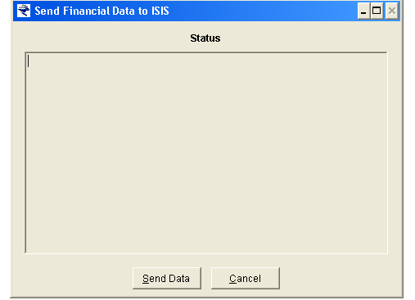

- Click on the Send Data button.
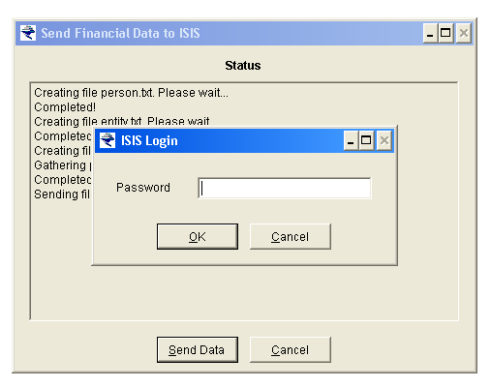

- As prompted, making sure that CAPS lock is turned off, enter your ISIS password.

The Billing Software will now send the billing data to the campus servers. During this process, you will see a series of messages appearing in the window.

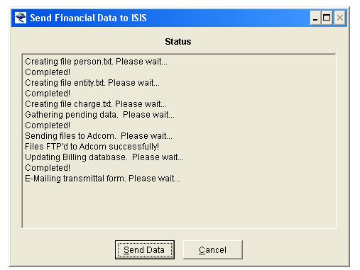

Once the file transfer is complete, you will see the following message:

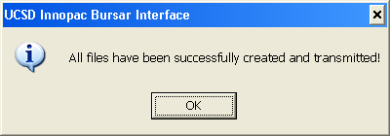

- Click OK to acknowledge the message.

The billing transactions from the recent transfer will now be listed in the Session Activity file for the current date under the Transactions module.

48. Exit the application.

VIEW PATRON HISTORY

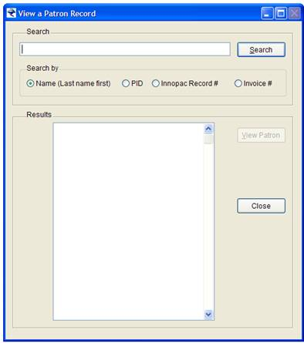

We access it via a “Patrons” drop down menu and then select the View Patron History option. We can search the historical database by patron name, PID, ILS patron record number or transaction invoice number (controlled by a radio button selection). The search criteria is entered into the designated text box and the search results appear as a list in the Results box:

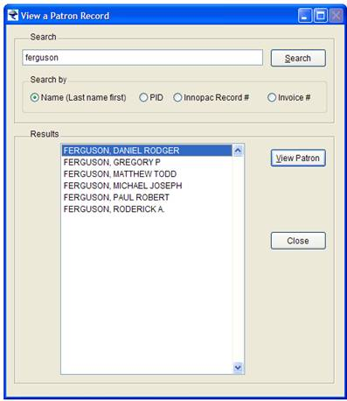

We then click on the record or patron that we are interested in looking at and then click View Patron to display their history information:

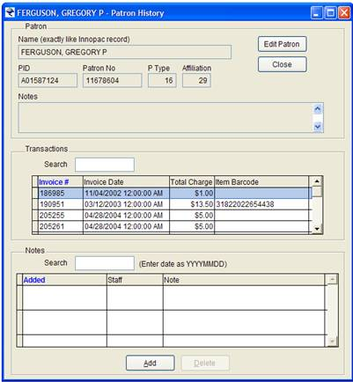

SESSION ACTIVITY MODULE

The purpose of the Session Activity module is to provide the user with a resource of prior days transactions sent to campus. It is a primary part of the verification process that occurs the day after a file is sent.

Upon selecting the Session Activity option in the Transactions menu, the program displays a “Session Activity” window:

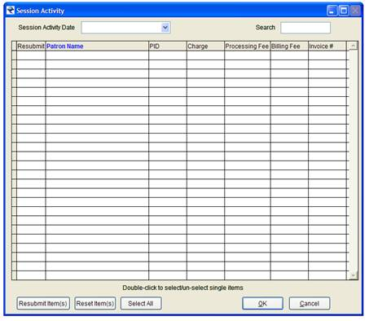

The staff member can then click on the “Session Activity Date” drop down menu and click on a date for a previous day’s transaction list:

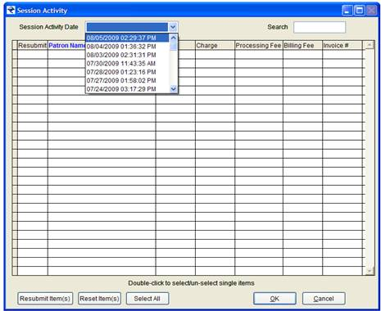.

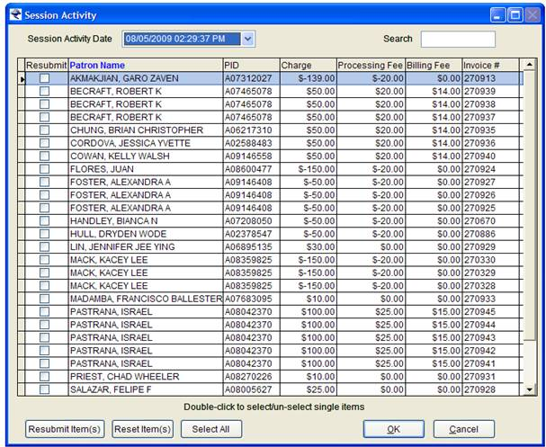

Procedurally, Library staff then accesses the campus billing system and confirm that the specified transactions were properly posted. Essentially, this is our mechanism to ensure that the charges and credits went through. If they did not, then we need to resubmit them.

If a transaction, or the entire file of transactions, is determined to have not posted, the Session Activity module provides us with a resubmit option, whereby a single transaction, multiple transactions, or all of the transactions in the list can be selected and marked for resubmission. Practically speaking, my selecting an item for resubmit, we need the billing application to place the specified transactions into the Pending Queue again for the purpose of being resent.

In the current application, staff select the specific transactions that they want to resubmit and then click on the Resubmit Item(s) button. A check mark will then appear in the adjoining check box in the “Resubmit” column. To authorize the selection and move the transaction into the Pending Queue, the staff member then clicks OK.

If an item(s) is marked for resubmit and the staff member wants to deactivate that selection, they click on the Reset Item(s) button.

STRUCTURE OF THE TRANSMITTED EMAIL TO ADCOM

patron billing application should send a transmittal confirmation email to act-prodcontrol@ucsd.edu when the user send the daily output file to them for processing. The format of the email should look like this:
__________________________________________________________________
Adcom Production Control
User Information
================
Date: MM/DD/YY
Department: Library
Contact: Department of Business & Finance
Email Address: Department_of_Business_and_Finance_Q&A@AD.UCSD.EDU
Phone: 858 534 5621
Mailcode: 0175M
File Description: Accounts receivable batch input files
From: Insert Library Staff Members Name*
Record Length: 320 characters
FILE DATASET NAME ( =Julian date) RECORD COUNT
AR CHARGE: SISP.ARD2502.LIBCIR.CHARGE.D09MMDD =
AR ENTITY: SISP.ARD2502.LIBCIR.ENTITY.D09MMDD =
AR PERSON: SISP.ARD2502.LIBCIR.PERSON.D09MMDD =

Date input file is to be processed: MM/DD/YY

III. Downloading and Processing Patron Billing Data
Updated Fall 2008

Using the Bursar Interface software, Library billing staff may download payment information for library related fines and replacement bills.

Downloading Daily Payment Information into INNOPAC

- Access the Bursar Interface application on your local machine.

The program will then open and begin the process downloading the latest payment data. Once the data is collected, the program will display a window similar to this:

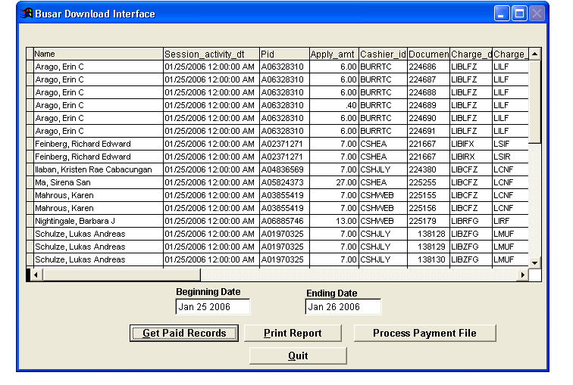

NOTE: The “Beginning Date” and “Ending Date” are automatically set when you start the program. The beginning date is based on the last date that a file was processed. The ending date is the current date. If you wish to manually adjust the date settings, you need only click into the respective text box and enter the information.

- To process the data into a file for importation into INNOPAC, click on the Process Payment File button.

Once the software processes the data, you will see the bottom of the data table in the window and the Process Payment File button disappears; for example:

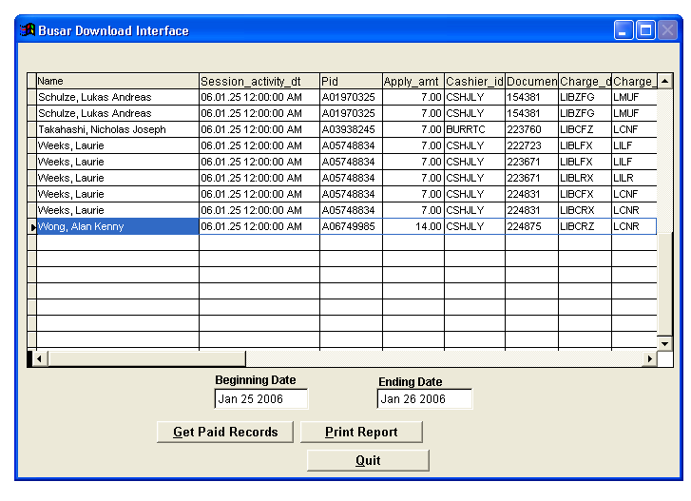
The software is programmed to automatically place the data file onto the f: drive of your local machine.

- Click on the Quit button to exit.

- On your desktop, double-click on My Computer.

- Within My Computer, double-click on your P: drive.

- Within your P: drive, locate the Billing – CIRC folder and double click on the icon.

- Once within the folder, sort the files by Date Modified and locate the current payment file. The naming convention for payment files is “bursarMMDDYY” (where MM = Month, DD = Day, and YY = First two digits of year)….for example the file name for January 26, 2006 is “bursar012620”.

- Single-click on the daily payment file to select it.

- Once you have selected the payment file, right-click and from the menu that appears click on the Cut option.

- Browse back to your general My Computer display and double-click into ‘billing_circ on anfalas’.

- Once in this folder, right-click and from the menu that appears click on the Paste option. The payment file should then appear.

- Close the drive window.

- On your desktop, double-click on your Roger icon.

- When prompted, enter your login (i.e. culcirc) and password.

- From the main menu screen, enter C > CIRCULATION subsystem.

- Next, from the menu provided, enter A > ADDITIONAL circulation functions.

- Then, from the menu provided, enter F > FINANCIAL functions and enter your INNOPAC initials and password.

- Next, from the menu provided, enter I > INPUT from bursar’s office and enter your INNOPAC initials and password.

- From the menu provided, enter G > GET payment data from bursar’s office.

- When prompted, enter a file name; for example “pay012606” and press Enter.

- From the list of IP addresses that will appear, select the line number that corresponds to IP 132.239.119.230.

- When prompted, enter the username “anonymous”.

- When prompted, enter your full UCSD email address (i.e. jsmith@ucsd.edu) as the password.

INNOPAC should then display the following screen:

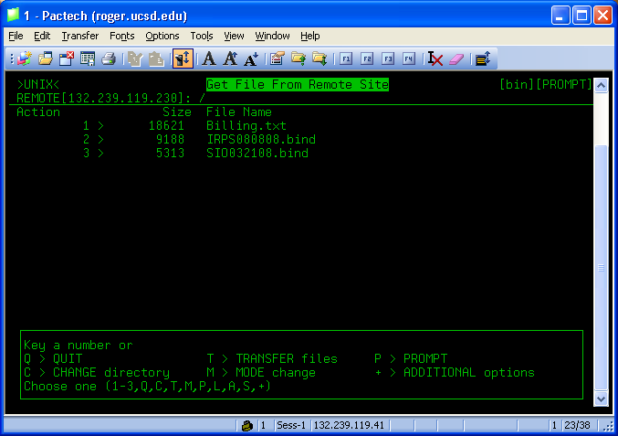

- From the menu provided, enter C > CHANGE directory.

INNOPAC should then display the following screen:

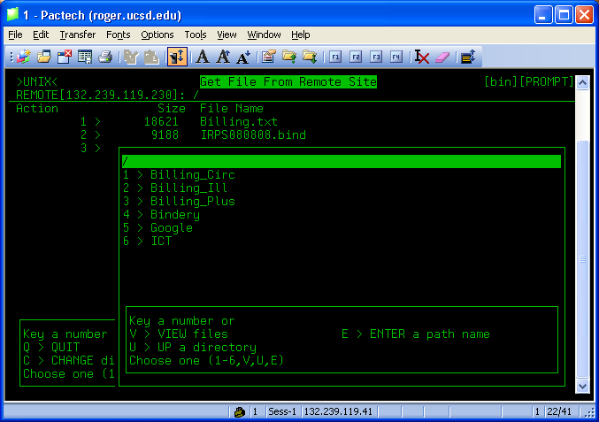

- From the menu provided, select the option for Billing_Circ (#1 in the above example).

- From the next menu provided, enter V > VIEW files.

INNOPAC should then display the following screen:

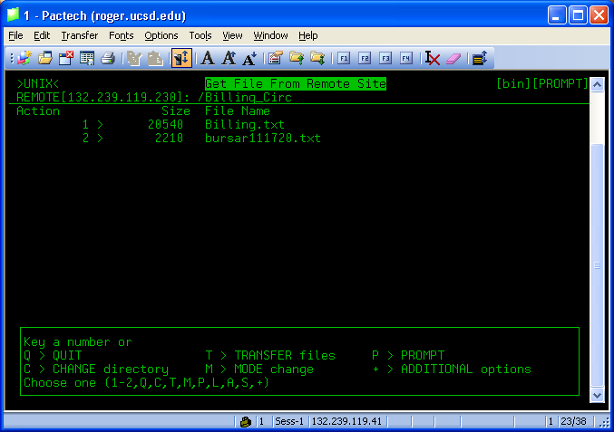

Notice that after the IP address (above left of screen) that the billing_circ folder is now listed.
INNOPAC should then display the following screen:

- Enter the line number of the payment file (2 in the above example). Upon doing so, the term “GET” should appear to the left of the line number.

- From the menu provided, enter T > TRANSFER files.

Once the file is transferred, INNOPAC will display a message indicating that the job was successful.

- When prompted, rename the file using the file extension .bur (i.e. pay012606.bur) and press Enter.

- From the menu provided, enter C > CONTINUE.

- From the menu provided, enter Q > QUIT.

- When prompted, press the SPACEBAR to continue.

INNOPAC should then display the following screen:

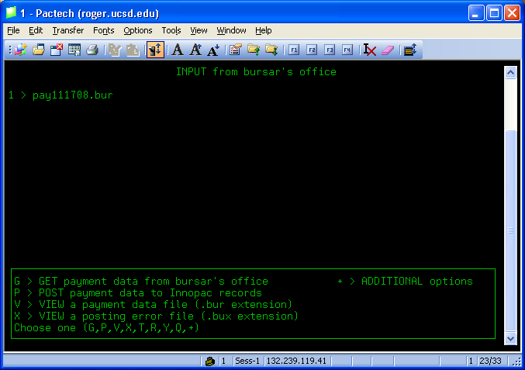

- From the menu provided, enter V > VIEW a payment data file (.bur extension).

- When prompted, enter the line number for the .bur file (1 in the above example).

INNOPAC should then display the following screen:

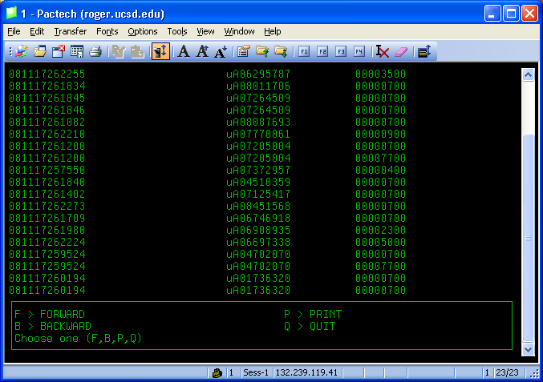

- VERY IMPORTANT!!! At this point, Library billing staff should review the list, using the F > FORWARD and B > BACKWARD options to move up and down. Each row is a payment transaction. The first cluster of numbers is the date of payment (YYMMDD), followed by the invoice number (224686 in the first line of the example above).

Library staff should go down the list and review all invoices that are duplicated one after the other. Since many library charges are split into two parts, duplicate invoice listings in the payment file is not unusual. However, due to payment and adjustments application issues with the campus billing system, sometimes the payment data for patrons with multiple charges are not evenly distributed between the invoices.

Library staff should identify the duplicate invoices in the list and review them for uneven payment amounts. If necessary, payments might need to be confirmed on IFIS/ISIS and collected manually prior to loading the payment file. Not doing so may create negative amounts in the patrons MONEY OWED field, causing more work later for library staff to clean up.

- Once the list is reviewed and all problematic issues dealt with, enter Q > QUIT and as prompted, press SPACEBAR to continue.

- Next, enter P > POST payment data to Innopac records.

- When prompted, enter the line number associated with the .bur file that you wish to load.

INNOPAC will then display some specifics regarding the data in the file, including the number of payments and the total amount being marked as paid.

- From the menu provided, enter C > CHECK validity of each entry.

This process reviews each payment transaction in the file and confirms if there are any problems with unidentified lines (i.e. no matching patron account number or PID) or missing invoices. Once the system completes the review it will display the message, “Checking complete.”

- As prompted, press SPACEBAR to continue.

If INNOPAC identified any errors during validation, the system will display the number of errors it found.

- If INNOPAC identified errors, next enter E > View ERRORS.

INNOPAC will then generate an error report. Using F > FORWARD and B > BACKWARD options, you can move up and down through the report. Ignore any “INV NOT FOUND” (invoice not found) messages as these payments have already been collected. If an error message appears indicating that no patron record was found, then copy the A-number in the error line and confirm the patrons name is IFIS/ISIS. Once you have the patrons name, retrieve their patron record in MilCirc and insert the A-number into their PID field.

- Once the error report is deemed safe, enter Q > QUIT.

- Finally, enter U > UPDATE patron records from valid entries.

INNOPAC will now post the payments. In some occasions, a patron record may be in use by the system when attempting to post a payment. If this occurs, INNOPAC will display the number of patron records not updated in a “# of Records in use” line. If this value is 0 after loading payments, then enter Q > QUIT.

However, if this value is greater than 0, then you must select the U > UPDATE patron records from valid entries option again. Repeat this process until the “# of Record in use” display is 0.

- If an error file is created (with file extension .bux), simply delete it from the system by selecting R > REMOVE file.

- From the menu provided, enter Q > QUIT to exit the module.

IV. Globally Purging Negative Charges in Patron Records

Occasionally, negative invoices appear in our patron records. This can occur for two reasons:

- On the campus IFIS/ISIS system, where we send our bills, fines and credits for collection, credits for items that had been billed for replacement and subsequently returned, are sometimes not posted to the correct invoice. The result of this is an invoice that either collected too much or too little.
- As a result of the IFISI/ISIS posting problem, we sometimes download “payments” that are for amounts over the amount we list as being outstanding for said invoice in our circulation system. In addition, the circulation system allows for the collection of these larger amounts, listing the difference as a negative invoice.

At least every two weeks, these negative invoices must be removed from our patron records because they counteract subsequent positive charges, possibly resulting in a patron’s privileges remaining active when they should be blocked due to owing too much money. In addition, it is imperative that our records are kept accurate.

Part 1 - To purge negative charges from our patron records:

- Login to the character-based INNOPAC system with a login that includes the File Save printer option. See the Circulation Systems Manager for the login and password if necessary.
- From the main menu, migrate through the following menus:

- C > CIRCULATION subsystem
- A > ADDITIONAL circulation functions
- F > FINANCIAL functions, enter passwords
- G > GLOBALLY purge fines, enter passwords

INNOPAC will then display the following screen:

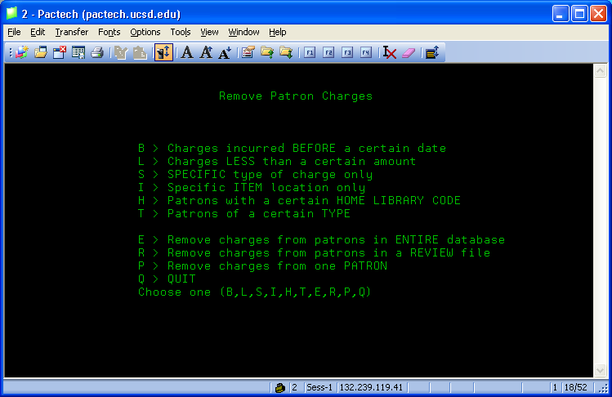

- Press L > Charges LESS than a certain amount. The ILS will then ask:

“Remove all charges less than$”

- Enter the amount $0.01. Upon doing so, the system will return you to the Remove Patron Charges main display. NOTE: You cannot enter $0.00.
- Press E > Remove charges from the patrons in the ENTIRE database. The system will then switch to the REMOVING OUTSTANDING CHARGES display and show you the criteria that you entered for the purge, for example:

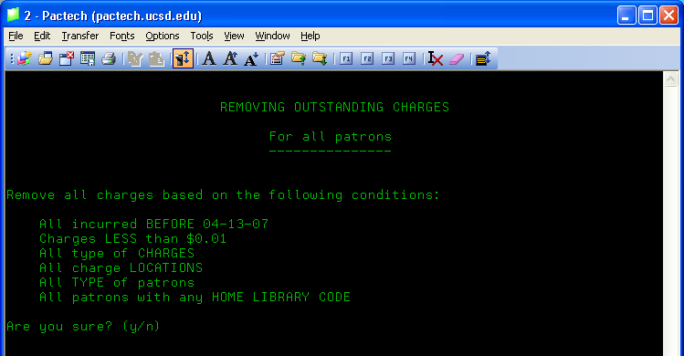

- Verify the purge criteria. It should be identical to the example above (save for the date, which should be the current date).
- Enter Y to confirm your purge criteria. The ILS will then ask you if you want to transfer the removed charges to the FINES PAID file.
- Enter Y to authorize this transfer and storing of information. The system will then begin the purge process, checking every patron record in our database:

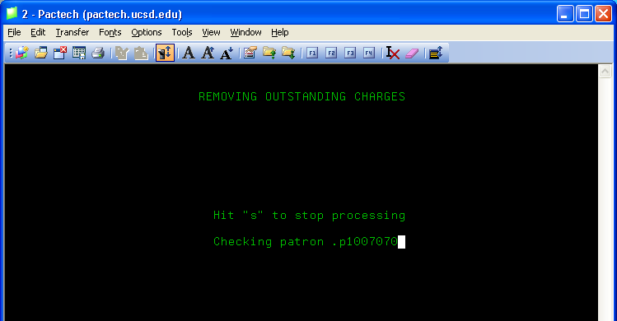

- Once the process is complete (it will take several minutes), the system will display a brief report detailing the number of patron records updated and the total amount cleared.
- Press Q > QUIT to exit from the GLOBALLY purge fines module, returning to the FINANCIAL functions screen.

Part 2 – Exporting the Fines Paid File

- Following step #10 above, you should now be on the FINANCIAL functions main menu screen. Here, press P > Examine fines PAID file and when prompted enter your ILS initials and password.
- Press D > List DAILY receipts and the system will display a table of receipt information.
- Press D > Display DETAIL. The system will then prompt you for a date range.
- For both date entries, enter today’s date (i.e. the date you ran the purge program).
- Once the table displays, press P > PRINT. The ILS will then display a list of printer options:

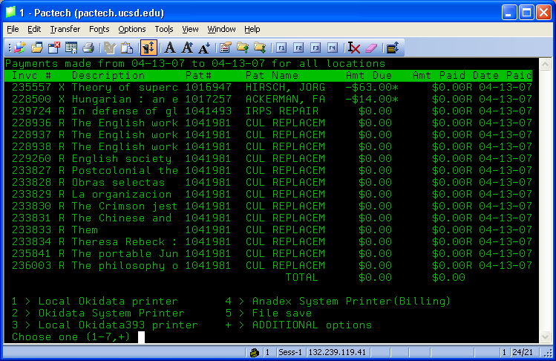

- Locate and press the option number for the File Save printer (#5 in the above example). The ILS will then ask you if the File save option is ready.
- Press Y to acknowledge this question. Next, the system will ask you to enter a file name.
- Enter an appropriate file name and press Enter.
- Exit from the character based system and log into Millennium Circulation using a login that includes the Data Exchange module. See the Circulation Systems Manager for login information and permissions.
- In MilCirc, set your initials and password.
- Click on the Data Exchange button.
- In the Data Exchange module, locate the Select Process drop down menu and select the ‘Send PRINT FILE out of INNOPAC using FTS’ option. MilCirc will then display a list of all file saved files.
- Locate your file in the list and single-click on it to select it (highlighting its row blue).
- In the upper right section of the window, click on the Put PC button. A Save dialog will open.
- In the Save dialog, browse to where you want to save the file, then click the Save button.
- Now that the file has been exported, make sure that it is selected in the MilCirc list and click on the Delete button. Then, when prompted, click on the OK button to affirm the deletion.

Part 3 – Verification

After running the global purge of negative charges, billing staff should then verify that each patron record affected is listing the correct billing information. To do so, staff must organize the fines paid data and compare the current billing information for each patron record to their respective IFIS/ISIS account.

- Browse to and locate the fines paid file that you exported out of the system.
- Rename the file extension, changing it to a text document (.txt).
- Using Microsoft Excel, open the document. Excel will display a text import wizard and identify that the file has fixed width columns:

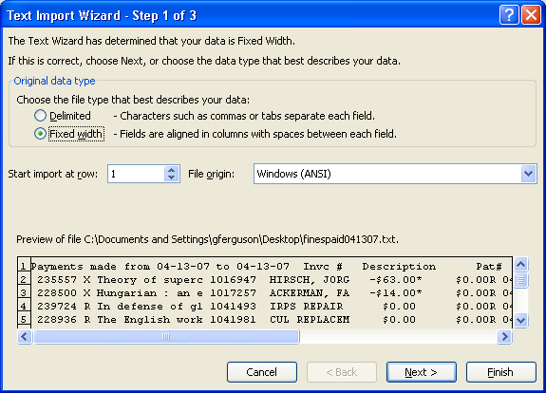

- Leaving the ‘Fixed Width’ radio button selected, press the Next button in the Text Import Wizard dialog. Excel will then display a second dialog:

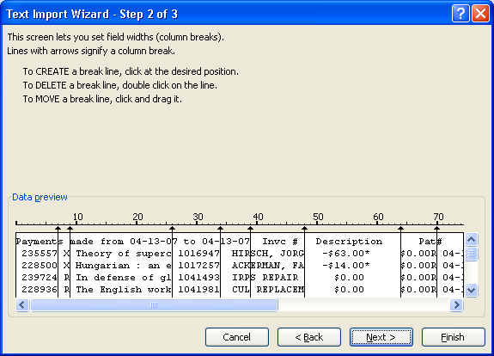
- Within the bottom section of this dialog, you will notice vertical lines separating sections of the data. Locate and double-click on those vertical lines that bisect columns, particularly the patron name column.
- Once the line or lines are removed, click on the Finish button. The data will now appear in an Excel spreadsheet.
- Select and delete the unnecessary columns. Ideally, you only need to retain these columns: patron name, amount paid, and date.
- Sort the remaining columns by the amount paid field and delete all of those rows with an amount paid value of either a $0.00 or higher. Ideally, you want a list entirely comprised of negative values.
- Next, sort the remaining information by patron name.
- Finally, using both MilCirc and the IFIS/ISIS systems retrieve the respective records and verify that both list the same billing information for each patron. If there is a discrepancy, report this fact to the SSHL Circulation Manager for possible handling.

